**GEOMETRIC OPERATIONS**

Different from point operations. Here the position of pixels change. In point operations the intensities of pixels change:

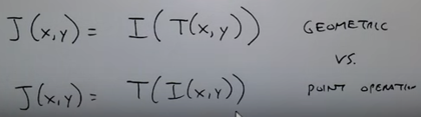

1. ***Translation:***



1. ***Scaling:***



1. ***Flipping:***



Representing in 2D

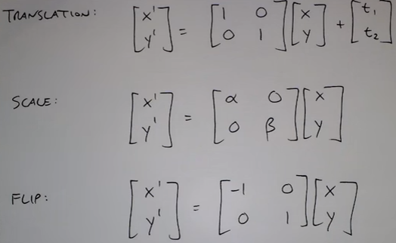

Flipping is a special case of scaling.

1. ***Rotation:***

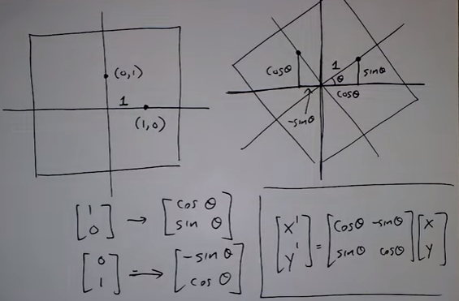

Any combination (scale, shift, rotate) of the above is called a similarity transformation.

It preserves parallel lines

If alpha and beta are +/- 1 it is called isometric transformation

It preserves shapes and angles

1. ***Bending:***

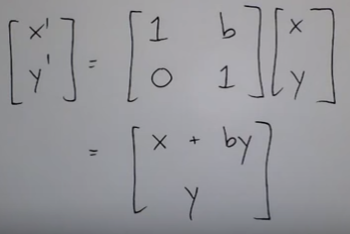

Shear:

